TRAUMA RESUSCITATION SCENARIOS WORKSHOP PRE-READING
EMET TRAUMA WORKSHOP BAROSSA MAY 2021
©Dr Tariq Nehvi (Program Lead)
Dear course registrant
Thank you for your participation in this educational and skills based activity, focused on the early management of trauma patients.
One of the important aspects of this activity will be your involvement in a low to moderate fidelity trauma resus simulation scenarios that you will be participating in as a team member/team leader.
The following reading is specifically with regard to these scenarios so please read carefully before coming to the course as it contains important details, instructions and explanations as well as highlights some important concepts relevant to the early management of severe trauma.
- Major trauma patients initially treated at a rural hospital should be transferred to a major trauma referral hospital as early as possible.
They may require life saving interventions at the peripheral hospital/at the scene.
Studies have shown that major trauma patients treated at rural/peripheral hospitals fare worse overall in terms of morbidity/mortality. Therefore, the primary goal, after addressing any immediate life threats should be to minimize delays in transfer.

The need for any lengthy/un-necessary imaging or procedures at peripheral hospitals should be discussed early with the receiving hospital trauma service or retrieval service.

- What needs to happen in ED?
The roles of the ED with respect to managing a severe trauma patient are:
Receive the pre-notification and activate an appropriate hospital trauma response
Receive the patient.
Commence initial assessment and appropriate resuscitation (especially life threats)
Coordinate further investigation and management
Refer to the appropriate in-patient service or external trauma service facility.
Arrange a timely and appropriate, safe disposition and transfer.

- Pre-Notification
This is vital. It gives valuable and very useful information about the patient’s status, immediate needs and provides a critical lead time and preparation time to the ED team.
It is best taken using the mnemonic AT-MIST.
When taking details from the pre-notification, it is very helpful to note these down in the following order:
A – age
T – time of event

M – Mechanism (this is very important and unfortunately, often not taken seriously enough)
I – Injuries – confirmed or highly likely/potential
S – (vital) Signs – Note any change/deterioration in these en-route when patient arrives
T – Treatment given so far, especially fluids, analgesics, other interventions etc (
During the simulations, the designated team leader should record the pre-notification details in this format, i,e AT - MIST.

- INITIAL ASSESSMENT (ALSO CALLED PRIMARY SURVEY)
Please note that the terms assessment and survey could be misleading because in real life, assessment and management need to occur simultaneously, especially when there are imminent life threats present.

A designated trauma resus team leader should already have been identified during/soon after the pre-notification stage. The leader then allocates roles and tasks to the team members depending on the immediate clinical needs of the patient who is en-route and subsequently oversees and ensures that the tasks are carried out AND also checks that a response/no response to an intervention or completed task has occurred.
(An exception to this would be when you are the only clinician available, say for example if multiple trauma patient’s arrive at the same time or in smaller units).
Please study the following flowchart:

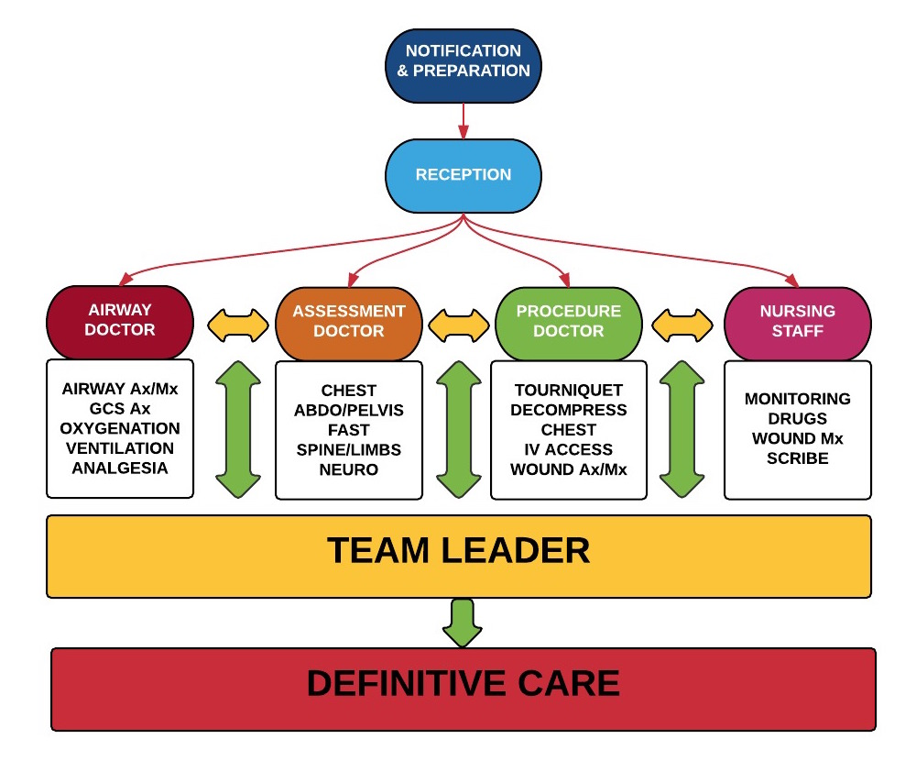

As you can see from the above flow chart, the “trauma” team at a minimum needs:
TEAM LEADER – leads the resus, allocates tasks, maintains communication and oversees
AIRWAY DOCTOR – Assess status of airway, manages airway as per imme (see diagram)
ASSESSMENT DOCTOR – Completes a primary assessment as shown above
PROCEDURE DOCTOR – carries out initial/life saving procedures as needed (see diagram)
NURSING STAFF – e.g, airway support, transfusion, medications, dressings, splints, scribe
OTHER SUPPORT STAFF
Note: Who makes up a trauma team will depend on the location of the hospital and the resources available and we appreciate that in most rural settings, it might just be a doctor and a nurse. In those situations, the tasks will obviously need to be carried out in series in the order of clinical urgency/life threats.
All the above team members work “in parallel” under the instructions of the team leader in reality.

What is a “TEAM” ? Well, you will have to tell me on the day
Try to be an expert team (rather than a team of experts) – the team members may have differing goals or roles/tasks at any point of time but the ultimate/overall OBJECTIVE is to achieve the BEST OUTCOME FOR THE PATIENT.
DO NOT HESITATE TO ASK/CLARIFY/CLEAR DOUBTS/SPEAK UP IF SOMETHING DOESN’T FEEL OR SOUND RIGHT.

Please note: During any time critical or stressful team based activity, like resuscitation of a critically unwell patient (trauma or non-trauma), one of the most important determinants of the outcome is COMMUNICATION. Breakdown in communication is the single most important factor associated with adverse outcomes.
To ensure that a task/order/instruction has been communicated and received as intended, the CLOSED LOOP style of communication has been shown to minimize miscommunication and avoid ambiguity.
For example, when a team leader is giving an instruction about a task to the airway doctor:
TL - “Doctor A – are you competent and capable of assessing airways?”
Doctor A – “Yes, I am” (or says otherwise if that is the case).
TL – “OK, that’s great. I would like you to assess the patient’s airway as soon as they arrive and update me regarding the status of their airway, especially if there is need for any immediate interventions..”
Doctor A then closes the loop by repeating back: “OK. I shall assess the patient’s airway as soon as they arrive especially if I feel the need for any immediate interventions”.
OR, if the TL wants the procedures doctor to do certain task/s:
TL: “Doctor P – could you please do perform a right sided finger thoracostomy now, and after you have done that, could you please insert a right sided intercostal chest drain..”
Doctor: “OK. I shall perform a right finger thoracostomy and then insert a right intercostal chest drain..”
“Closing the loop” is a great way of ensuring that there is clear and complete understanding of the tasks/roles/instructions between the TL and team member.
WHAT DO WE DO ON INITIAL ASSESSMENT:
Note: Although the following actions appear to be occurring in sequential steps, in reality, all actions will need to occur in parallel and any threats identified will also need to be actioned urgently by the team members, under the directions of the TL.
Expose/undress the patient fully (but beware of hypothermia!)
Attach physiologic monitoring equipment – NIBP, ECG trace, Sats probe, Temperature, RR.
Control any obvious external haemorrhage (pressure, torniquet etc). Torniquets are now commonly used by Australasian Pre-Hospital services to control life threatening or exsanguinating major limb bleeding. It would be a good practice to stock (and / or familiarize yourself with) a torniquet ( eg SOF T torniquet)

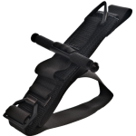
A SOF Tactical Torniquet

Caution: Always record the time of application of a torniquet. If a patient arrives with a torniquet in-situ that appears to be effective (no ongoing significant haemorrhage distally), it should not be removed unless there is a surgeon present or patient is in an OR). However, ineffective torniquet or incorrectly applied torniquet could do more harm and should be re-applied/reinforced if needed.
Assess and manage airway and Cervical spine:
If the patient is conscious and talking comfortably, one can safely conclude that there is no imminent threat to the airway and move on to the next steps.
If you are allocated an airway doctor role, it is vital that you begin airway assessment straightaway and then update the TL about your findings/recommendations regarding any immediate management needed.
In patients with a decreased conscious state or any other condition that maybe compromising their airway patency, high flow oxygen and basic airway maneuvers should be instituted (caution C spine injuries) to temporize the situation in preparation for any subsequent definitive airway intervention.
REMEMBER: OXYGENATION (AND NOT INTUBATION) IS THE INITIAL GOAL AND ALL INITIAL ATTEMPTS SHOULD BE MADE TO ACHIEVE ADEQUATE OXYGENATION BY AS SIMPLE AND EFFECTIVE MEANS AS PRACTICABLE).
If not already, please familiarize yourself with the VORTEX approach to airway management. This is especially important in case of predicted difficult airway management (which all trauma related airway management can potentially be).
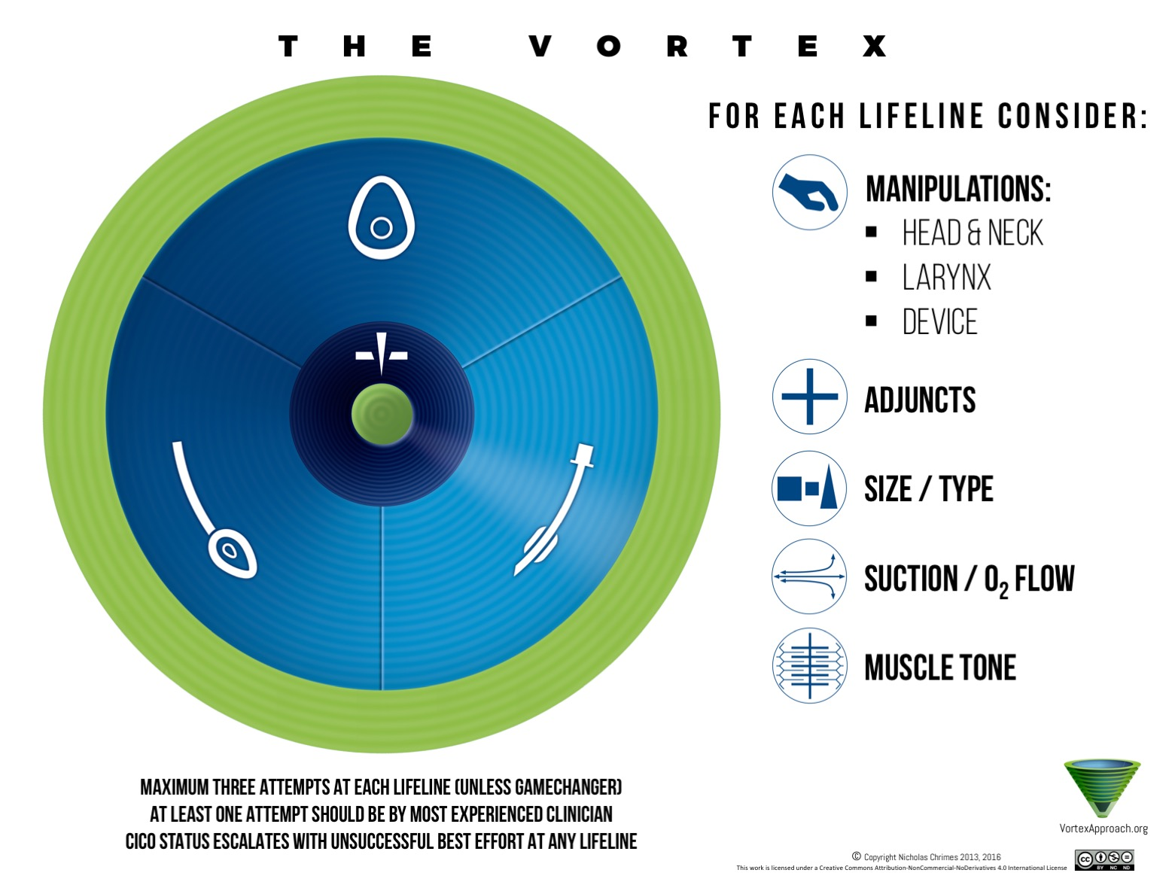

CICO – “Can’t intubate, can’t oxygenate” situation needs a prompt front of neck access (FONA)

THE ANTERIOR NECK:
While we are often (and for good reason) focused on the posterior neck when assessing for neck injuries (for example posterior mid-line tenderness), we should not forget the anterior neck!
Remember that the anterior neck contains vital airway and vascular structures and a C collar may conceal or worsen any injuries to these. In the worst case scenario, the C collar may actually worsen airway compromise.
Note: In Australia and NZ, several ambulance service organisations have stopped using Stiffneck hard collars and replaced them with soft collars. However, some states still use the hard collars.
- Never force/fix a hard C collar in an agitated trauma patient as it is possible to damage the neck further if the head is immobilized while the rest of the body moves.
You should always open the C collar, with an assistant providing in-line stabilization while you assess and inspect the anterior neck. The pneumonic TWELVE C is useful when assessing for features of any life threatening conditions in the neck:

T – Tracheal deviation (Tension Pneumothorax)
W – Wounds and Swelling – vascular injuries and haematomas (especially pulsating or expanding haematomas).
E – Emphysema – subcutaneous emphysema secondary to laryngo-tracheal, pulmonary or mediastinal injuries
L – Laryngeal crepitus – Laryngeal fractuture!
V – Veins. Distended neck veins with or without shock may indicate an actual or impending obstructive shock from pericardial tamponade or a tension pneumothorax.
E – OEsophagus: ability to swallow.
C – Carotids. Bruising, swelling and bruits (and/or any neuro-deficits).
It is important to remember that in addition to vertebral/cord injuries of the spine, one should keep in mind the likelihood of neck vessel dissection injuries, especially those of vertebral arteries and less commonly, carotid arteries. The chances of these injuries are significantly higher if a C spine fracture is present and one must keep a low threshold for imaging studies to rule such injuries in or out. Presence of seat belt marks/bruising to the neck increase the likelihood of such injuries.
It is also important to realise that the presence of neuro-deficits or abnormal neurological signs might be a consequence of neck vascular dissection injuries rather than direct cerebral or spinal injuries.

BREATHING AND CHEST TRAUMA
AIMS:
. Optimisation of ventilation and oxygenation.
. Rapid identification of any tension pneumothorax or haemo-pneumothorax with immediate decompression if present (procedure doctor should be instructed as soon as diagnosis strongly suspected or confirmed)
. Look for other life threats

Immediate life threats can be remembered using the mnemonic ATOM FC:
A – aortic transection – in reality, only ever diagnosed if patient survives to reach hospital and gets a timely and appropriate CT.
T – Tension pneumothorax or trachea-bronchial injuries
O – Open pneumothorax – occlude immediately with an occlusive dressing to cover any potential open sucking wounds (Note: 3 sided dressings are no longer recommended)
M – Massive haemothorax. Maybe obvious clinically but usually diagnosed on CXR or ultrasound.
F – flail chest: When a segment of chest wall becomes flail due to multiple rib fractures occurring at two different points. The “flailing” segment may be visible during inspiration (pushed out) and expiration (drawn in) which is paradoxical to what should normally happen during inspiration and expiration. This can quickly lead to worsening hypoxia and respiratory failure.
Good analgesia and sometimes positive pressure ventilation (usually by endotracheal intubation) are required to manage this. There is some evidence that non-invasive ventilation can be used initially to improve oxygenation and ventilation but this is unlikely to work well in the absence of good analgesia (typically, intercostal nerve blocks or serratus anterior plane nerve block)
C – cardiac tamponade. This will be detectable on the FAST scan - (refer to the attached video lectures on the FAST scan by Dr Alistair Murray). If a cardiac tamponade is present and the patient imminently crashing, this will need urgent decompression and via either a pericardiostomy and pericardial window drainage (temporizing measure as a desperate life saving intervention) or a formal resuscitative thoracotomy either at the scene(typically by pre-hospital retrievalists), in the ED or in the OR, depending on the location and the availability of resources and skills.

CIRCULATION AND CIRCULATORY SHOCK IN TRAUMA
It has always been taught and practiced in the past that a hypotensive trauma patient is bleeding and needs transfusion. Whilst in the vast majority of cases, this is true, one must bear in mind that:
In a shocked, hypotensive trauma patient, seek and immediately treat OBSTRUCTIVE SHOCK and GIVE BLOOD only if severe bleeding is present.

Once you are sure that bleeding is the cause of shock in trauma, the simple mantra to follow subsequently is

FIND THE BLEEDING
STOP THE BLEEDING (damage control surgery)
CORRECT DEFICIENCIES
BLOOD FOR BLOOD
KEEP PATIENT WARM
In short: AVOID SALINE. IF BLEEDING, GIVE BLOOD WHILE ACTIVATING ALL MECHANISMS/SYSTEMS TO STOP THE BLEEDING ASAP.
In haemorrhagic shock – two large bore IV access cannulas should be inserted but in cases of difficult IV access, Intra-osseous access should be obtained without further delay.
Remember, the wider and shorter the IV line, the faster the rate of flow. Use of pressure bags to transfuse is extremely useful!

If ongoing large volume blood/fluid resuscitation is anticipated, a Rapid Infusion catheter (RIC) should be inserted. This can usually easily be done by converting an existing IV cannula to RIC.
With the increasing use of IO as well as use of ultrasound guided vascular access, the need for a veinous cut-down is almost extinct now.
Comparison of various IV access device flow rates:
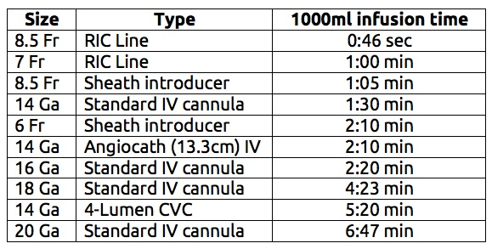
The current recommended end points of blood volume replacement in traumatic haemorrhagic shock are a systolic blood pressure of 80-90 mmHg (PERMISSIVE HYPOTENSION).
However, if there is a concurrent traumatic brain injury present, then permissive hypotension is not recommended and in these cases, aim for a higher systolic BP end point – 100-110mmHg.
Haemorrhage will fall into one of two categories:
- External/compressible bleeding
- Internal/Non-compressible bleeding.

External haemorrhage should already have been controlled, either pre-hospital or during the initial part of primary assessment as described above.
Internal haemorrhage may not be readily discernible initially. Reassuringly, if a patient has a normal level of consciousness, normal skin colour, normal vital signs, warm peripherals and no diaphoresis, they are unlikely to be at immediate risk from serious haemorrhage.
However, it is important to check and recheck vital signs especially after an intervention has occured – for example fluid bolus or blood transfusion has been given or chest decompression performed or application of a pelvic binder etc.

The following sites may conceal large volumes of internal bleeding in cases of haemorrhagic shock:
Abdominal cavity
Pelvis
Chest
Retroperitoneal space
Thighs (from femoral shaft fractures)
The goal is to look for bleeding in these spaces using a combination of clinical, bedside ultrasound (eFAST) and/or CT scanning (with urgency if hypotension is starting to trend down).
It requires clinical judgement and expertise/experience to decide whether a trauma patient with progressive hypotension is going to be stable enough for transfer to CT room or whether they are too unstable and therefore unsafe for that. In the latter situation, they should be sent to OR as expeditiously as for damage control surgery (hence the need for alerting the surgical services ASAP). Damage control surgery is primarily aimed at stopping the internal bleeding (rather than definitive surgical repair of injuries) and is now considered as a part of modern trauma resuscitation.

Bleeding into the chest
This will be picked up by any one of, or a combination of the following, during the primary assessment
Clinical assessment
CXR
eFAST
Intercostal chest tube drainage will be required in all but the most minor of bleeds in otherwise stable patients and almost ALWAYS with any size of haemothorax in unstable, shocked patients.
Note: Each pleural space can conceal upto 3 litres of blood loss!
A common mistake when decompressing a haemothorax is to clamp the chest drain if the haemorrhage is brisk. However, clamping the chest tube does not stop or stem the haemorrhage at all but rather impairs ventilation, conceals the true haemorrhage and and potentially leads to a tension haemothorax.
DO NOT CLAMP THE CHEST TUBE
Brisk or large volume haemorrhage from chest drains means that urgent cardiothoracic surgery intervention will be required. This should be arranged expediently while resuscitating the patient for haemorrhagic shock using blood/MTP etc.

Bleeding into the abdomen, pelvis and retro-peritoneum
This can be assessed by a clinical and/or radiological examination.
Certain examination findings can point to the potential existence of serious internal injuries/bleeding:
Seat belt/lap belt sign
Abdominal/flank pain, bruising, tenderness, abdominal wall guarding or rigidity.
The pelvis should be examined/palpated for tenderness by the clinician’s two hands placed over the iliac crests and a single, gentle medial- directed compression. Never do this more than once.
If significant pelvic injury or instability is already evident, there is no need to palpate the pelvis.
Most pelvic injuries associated with significant bleeding and causing haemodynamic instability are also typically radiologically and “orthopaedically” unstable although there can be exceptions to this.
REMEMBER: NEVER “SPRING” OR “ROCK” THE PELVIS. THIS MAY CAUSE CATASTROPHIC BLOOD LOSS IN UNSTABLE PELVIC FRACTURES!
The retroperitoneum can conceal significant amounts of bleeding and should be suspected as the site of blood loss if no other site seems to be showing evidence of bleeding on initial assessment. CT imaging should readily reveal retroperitoneal haemorrhage.
Pelvic Binders
These are probably most beneficial in the AP compression type or “open book” pelvic fractures.
There is no robust evidence that application of pelvic binders reduces mortality. However, there is reasonably good evidence that it reduces transfusion requirements.
It is reasonable to apply pelvic binders in severely shocked trauma patients if severe injury is suspected, and should be left in-situ until a pelvic injury has been ruled out by CT.
Application of pelvic binder routinely in stable trauma patients with no pelvic pain and normal vital signs is of no use and is discouraged.
Note: If you apply a pelvic binder in a shocked patient, remember to tie the feet together too.
If you apply a pelvic binder in ED, make sure you repeat a pelvic X ray soon after application to ensure that application has not worsened the pelvic fracture.
Any obvious femoral fractures/deformities indicate a likely femoral fracture. These should be managed pre-hospital or in ED by application of CT-6 traction splints. Application of such splints not only provides temporary stabilization of these severe fractures but also provide comfort and analgesia and reduce further blood loss at the fracture site.

FOCUSSED SONOGRAPHIC ASSESSMENT OF TRAUMA (FAST) and EXTENDED FAST (eFAST)
Should only be performed by trained/accredited clinicians with a reasonable familiarity with it.
It should NEVER solely be used to rule in/rule out an internal injury in a trauma patient.
It has best value in expediting decision making in the unstable trauma patient.
A negative FAST scan in a stable patient does NOT rule out significant internal injuries.
A positive FAST scan in an unstable trauma patient with no evidence of other causes of shock is generally accepted as an indication to transfer the patient expeditiously to the operating room (without a CT scan).
FAST SCAN IS A USEFUL ASSESSMENT AND DECISION MAKING TOOL AS IT ALLOWS PRIORITISATION AND DECISION MAKING IN TERMS OF URGENCY OF SURGICAL TREATMENT AND/OR TRANSFER TO A DEFINITIVE TRAUMA SERVICE.
Please do watch the excellent videos specially created for you by Dr Alistair Murray to help you understand the basics of performing and interpreting FAST scans. (Links attached in the email).

Useful tips regarding participation in the trauma simulation scenarios on the day:
The registrants will be divided into groups.
Each group will be given at least two trauma scenarios to manage. The group will choose a TL and rest of the team members.
The TL will take details during a pre-notification followed by a team – brief and role allocation.
TL to use the “AT-MIST” when recording the pre-notification details on the white board and then allocate roles and tasks to the team members.
All communication during briefing and allocation should be done using the “closed-loop” style.
All life-threats will need to be identified/suspected by the TL and communicated to the team, for example, “start high flow oxygen via non-rebreather mask”, “commence bag-mask ventilation” or “carry out RSI and intubation” (if the airway needs an appropriate intervention).
Similarly, the instructions might have to be to “perform a finger thoracostomy followed by insertion of a chest drain..” (if there is evidence of tension pneumothorax or a large haemothorax).
Critical interventions to address immediate life threats will need to be clearly directed by the TL and the allocated airway and/or procedures doctors/clinicians will acknowledge the instructions and feedback to the TL when the task/s is/are completed.
During the simulations, the TL should step back to ensure brief “time - outs” occur in order to review the situation/update progress especially after a critical intervention has taken place so that ALL team members are on the same page. This is called “shared mental model” and it ensures that every team member understands what is needed, what is happening and if there has been any improvement (or deterioration). It also gives an opportunity to share ideas/provide suggestions and clarify doubts.
Each trauma simulation scenario will last about 6-7 minutes followed by de-briefing and discussion about that scenario for another 6-7 minutes.

HOPE THIS HAS BEEN USEFUL.
GOOD LUCK ON THE DAY AND SEE YOU ON THE 19TH JUNE 2021.

Dr Tariq Nehvi
MBBS, FACEM, MRCS(Edinburgh)
Consultant, Emergency Medicine, LMH
Program lead, NALHN EMET program.
Email: Tariq.Nehvi@sa.gov.au

